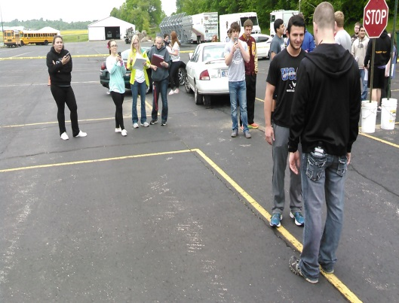
Criminal Justice
Pike Central High School
Dual credit Thru Ivy Tech 6 Credit hours
A two year program divided into 4 separate classes.
- Criminal Justice
  - Study of all parts of the Criminal Justice system
- Intro to Traffic Law
  - Enforcement of Traffic Laws and Accident Investigations
- Criminology
  - Scientific study of Crime and Criminals
- Criminal Investigations
  - Study of Criminal Investigations and forensic techniques
Who should take this course?
- Students interested in a career in:
  - Law Enforcement
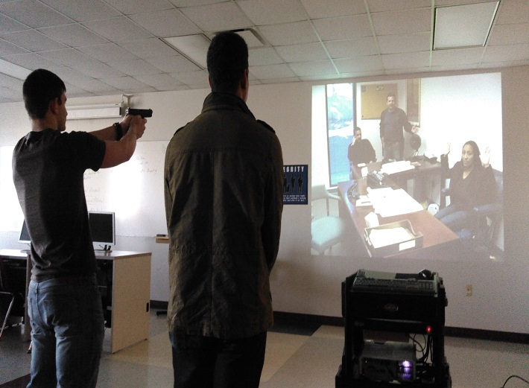
  - Corrections
  - Criminal Law
  - Probation
  - Forensic Analysis
